

GROUP ASSIGNMENT
CT077-3-2-DSTR
DATA STRUCTURES
APD2F2411CS(CYB)

HAND OUT DATE: 14TH MAY 2025
HAND IN DATE: 6TH JULY 2025
GROUP: P

No. | Student Name | TP number
1 | HEMANTHRAJAH A/L N KRISHNARAJAH | TP070844
2 | ANUSHA DEVY A/P BRAHMATARAN | TP071154
3 | DARMIK ISHWAR A/L RAVI | TP070071
4 | ADAM JEROME JOSEPH | TP071194

Table of Contents
1.0 Theoretical Explanation 3
1.1 Array and Linked List 3
1.1.1 Array 3
1.1.2 Linked List 4
1.2 Sorting Algorithm 5
1.2.1 Introsort 5
1.2.2 Merge Sort 5
1.3 Searching Algorithm 6
1.3.1 Linear Search 6
1.3.2 Binary Search 7
2.0 Input/Output Solution 8
2.1 Sort by Payment Channel 8
2.1.1 Output 8
2.2 Sorting Algorithm 9
2.2.1 Merge Sort 9
2.2.1.1 Output 9
2.2.2 Intro Sort 12
2.2.2.1 Output 12
3.0 Summary Discussions 17
3.1 Comparing Sorting Algorithm in Array 17
3.2 Comparing Sorting Algorithm in Linked List 17
3.3 Comparing Searching Algorithm in Array 18
3.4 Comparing Searching Algorithm in Linked List 19
5.0 Conclusion and Reflection 20
5.1 Conclusion 20
5.2 Reflection 20
6.0 Workload Matrix 21
6.0 References 22

1.0 Theoretical Explanation

1.1 Array and Linked List

1.1.1 Array
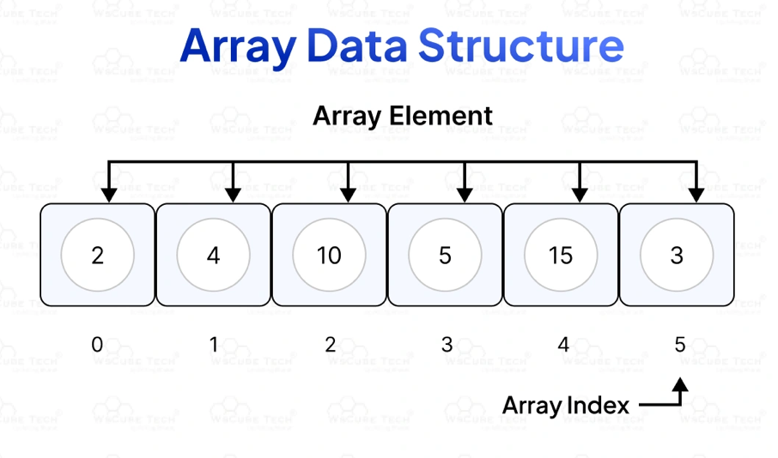
Figure 1: Array Data Structure

In C++, an array is a fundamental data structure created to store multiple values of the same data type in a single, continuous block of memory. It can be compared to a staircase, with each step holding a specific value. Just as a friend can be identified at a certain step, each value in an array can be readily accessed using its index. This structure allows for fast and predictable access to data since each element is located at a fixed offset from the starting point, or base address, of the array (GeeksforGeeks, 2023). While traditional arrays in C++ are of fixed size, meaning you must declare their length at the time of creation, many modern programming languages offer dynamically resizable alternatives built on top of fixed-size arrays such as vector in C++, ArrayList in Java, and list in Python (Chauhan, 2025). Arrays are also instrumental in building more complex data structures like stacks, queues, heaps, and deques. Their key strengths lie in cache efficiency and direct random memory access, making them highly performant for many algorithms (GeeksforGeeks, 2017). Arrays can store both basic data types like int or char and more advanced types like pointers or structures, which makes them a versatile tool in any C++ programmer’s toolkit (Chauhan, 2025).

1.1.2 Linked List
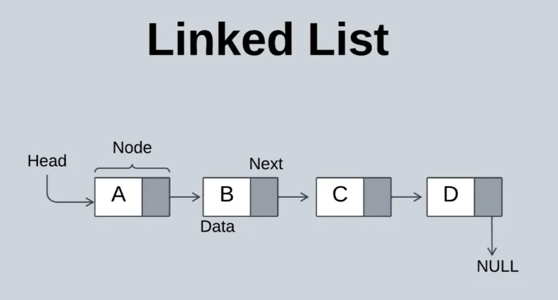
Figure 2: Linked List Data Structure

A linked list is a core data structure in computer science known for its flexibility in memory management and efficient insertion and deletion operations. Unlike arrays, which store elements in a contiguous block of memory, linked lists consist of nodes each containing data and a reference or pointer to the next node allowing the list to grow dynamically as memory becomes available (GeeksforGeeks, 2025; W3Schools, 2025). This non-contiguous memory structure enables linked lists to avoid the costly shifting of elements that arrays require when items are added or removed. Instead, updating a few pointers is typically enough, making operations like insertion and deletion faster and more efficient. However, because linked lists rely on sequential access, they are slower than arrays when it comes to accessing elements by index. Despite this, their dynamic nature makes them especially useful in situations where the number of elements is unknown or changes frequently. Additionally, linked lists serve as the foundation for more complex data structures like stacks, queues, and deques, making them an essential concept in data structure design (GeeksforGeeks, 2025; W3Schools, 2025).

1.2 Sorting Algorithm

1.2.1 Introsort
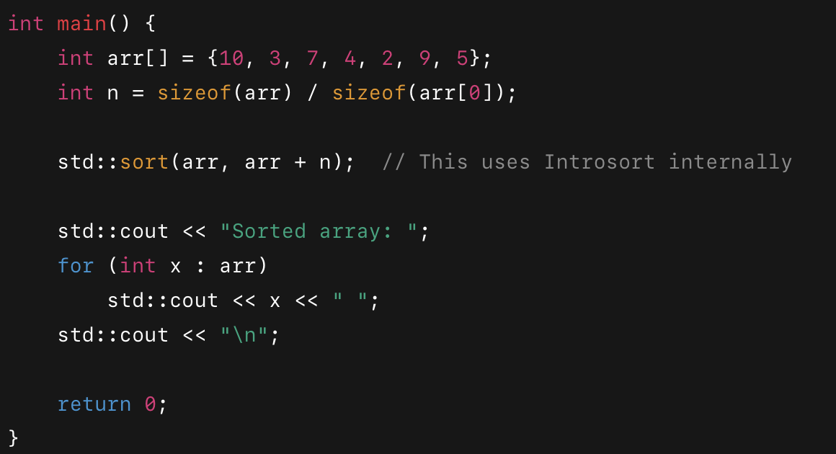
Figure 3: Example Code for Intro Sort

Introsort, short for introspective sort, is a powerful hybrid sorting algorithm used in modern programming languages like C++ (STL) and Swift. What makes Introsort unique is that it combines the strengths of three different sorting algorithms that are Quicksort, Heapsort, and Insertion Sort. This is to ensure fast and reliable performance across various data conditions (GeeksforGeeks, 2025). It begins by using Quicksort for its speed and efficiency. However, if the recursion depth exceeds a certain threshold (defined as 2 × log N), it switches to Heapsort to prevent Quicksort's worst-case time complexity of O(n²). For smaller partitions, typically fewer than 16 elements, Introsort uses Insertion Sort, which is more efficient for small datasets due to its low overhead (Dhanush, 2024). This adaptive switching makes Introsort significantly faster and more robust than using any one of these algorithms alone. Although Introsort is not a stable sort which means equal elements might not retain their original order, but it’s still considered one of the best general-purpose sorting algorithms in use today because it optimizes for both speed and reliability depending on the data it encounters (GeeksforGeeks, 2025; Dhanush, 2024).

1.2.2 Merge Sort

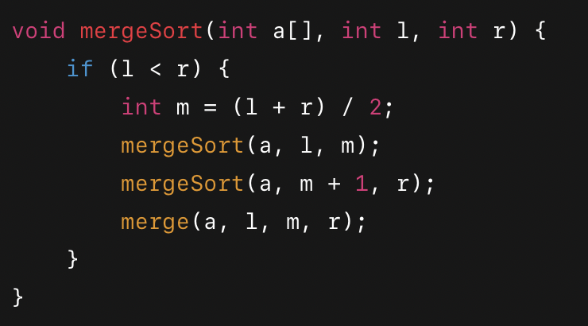
Figure 4: Example Code for Merge Sort

Merge Sort is a classic sorting algorithm based on the divide and conquer approach, where the main idea is to divide the input list into two halves, sort each half recursively, and then merge the sorted halves back together. This process continues until each sub-list contains a single element, which is already sorted. The merging step combines these sorted lists by comparing elements one by one and building a new sorted list (Programiz, 2025; W3Schools, 2025). Unlike sorting methods such as bubble or insertion sort, Merge Sort is more efficient for large datasets due to its consistent time complexity of O(n log n) in all cases such as best, average, and worst (BBC Bitesize, 2019). Additionally, Merge Sort is a stable sorting algorithm, meaning it preserves the order of equal elements, which is useful when sorting records based on multiple criteria.

1.3 Searching Algorithm

1.3.1 Linear Search

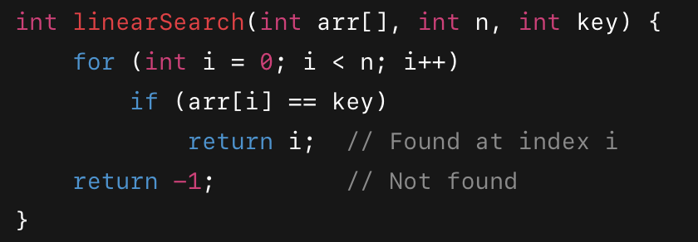
Figure 5: Example Code for Linear Search

Linear Search is one of the simplest searching algorithms used to find a specific element within a list or an array. It works by checking each element one by one from the beginning of the list until the desired element is found or the end of the list is reached (TutorialsPoint, 2025). While linear search is easy to understand and implement, especially for small datasets or unsorted lists, it is not the most efficient method when dealing with large data, as its time complexity is O(n) which means the time taken grows linearly with the number of elements (Simplilearn, 2025). The main advantage of linear search is that it does not require the data to be sorted, making it useful in scenarios where sorting is not feasible. Additionally, it works on any type of data structure, including arrays, linked lists, or even lists of objects (ScholarHat, 2025).

1.3.2 Binary Search

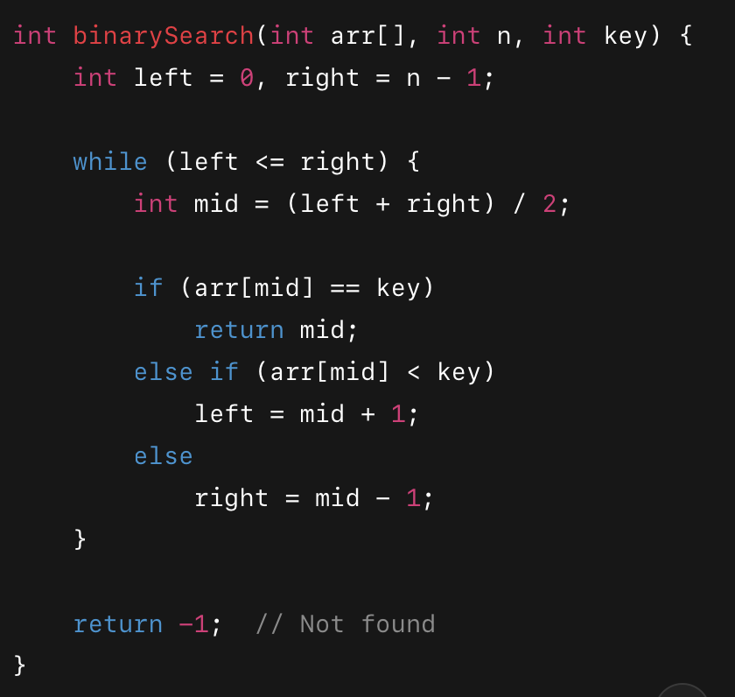
Figure 6: Example Code for Binary Search

Binary Search is an efficient algorithm used to find the position of a target element within a sorted array or list. It works by repeatedly dividing the search range in half comparing the target value to the middle element and then narrowing the search to either the left or right half depending on whether the target is smaller or larger (TutorialsPoint, 2025). This process continues until the element is found or the search range is empty. Unlike linear search, which checks every element one by one, binary search significantly reduces the number of comparisons, offering a time complexity of O(log n) (Programiz, 2025). However, it requires the data to be sorted beforehand, which is a key limitation. Due to its speed and low memory usage, binary search is widely used in applications involving large datasets and static data environments (PW Skills, 2025).

2.0 Input/Output Solution

2.1 Sort by Payment Channel

2.1.1 Output
Array

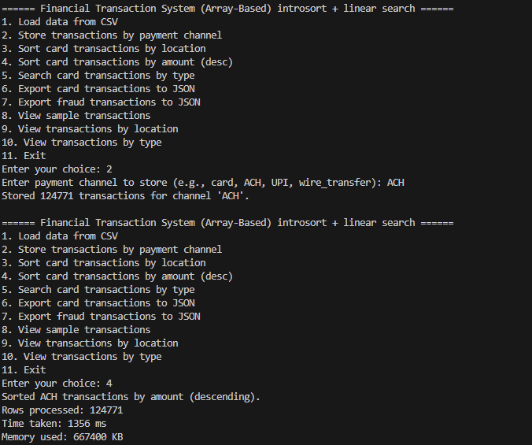

Figure 7: Output for Sort by Payment Channel “ACH”

Linked List
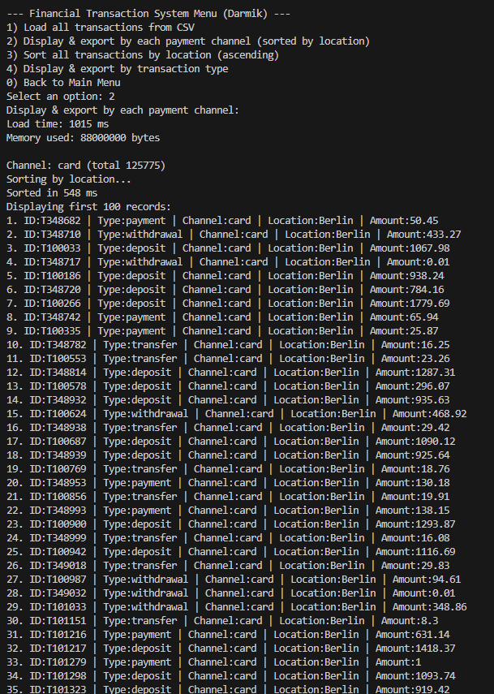
Figure 8: Output for Sort by Payment Channel

2.2 Sorting Algorithm

2.2.1 Merge Sort

2.2.1.1 Output
Array

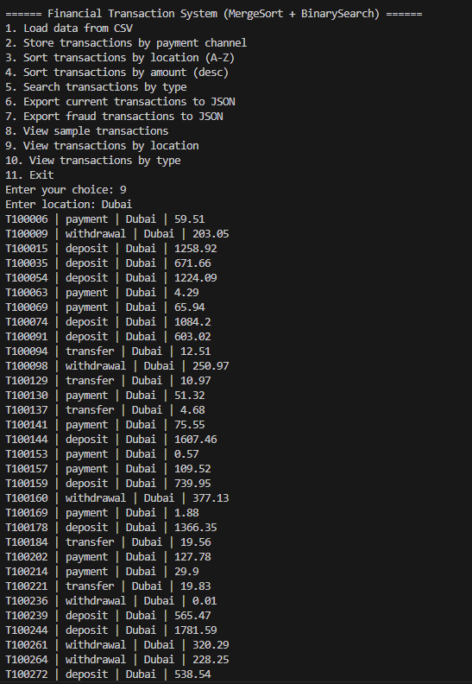
Figure 9: Output for Sort by location “Dubai”

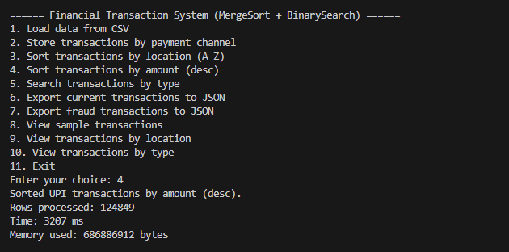
Figure 10: Output Sort by Transaction Amount in Descending Order
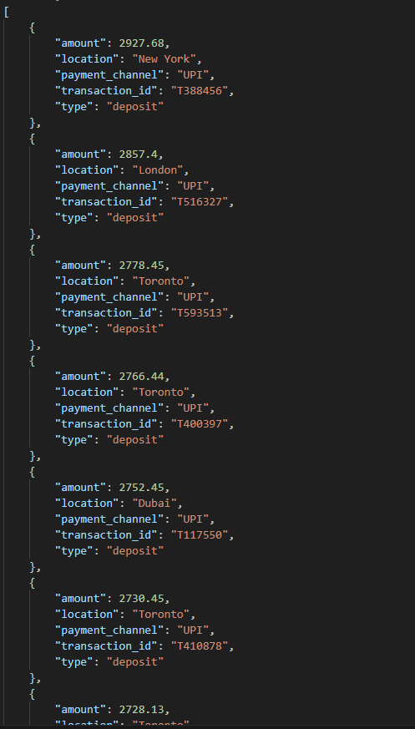
Figure 11: JSON Format for Amount in Descending Order

Linked List
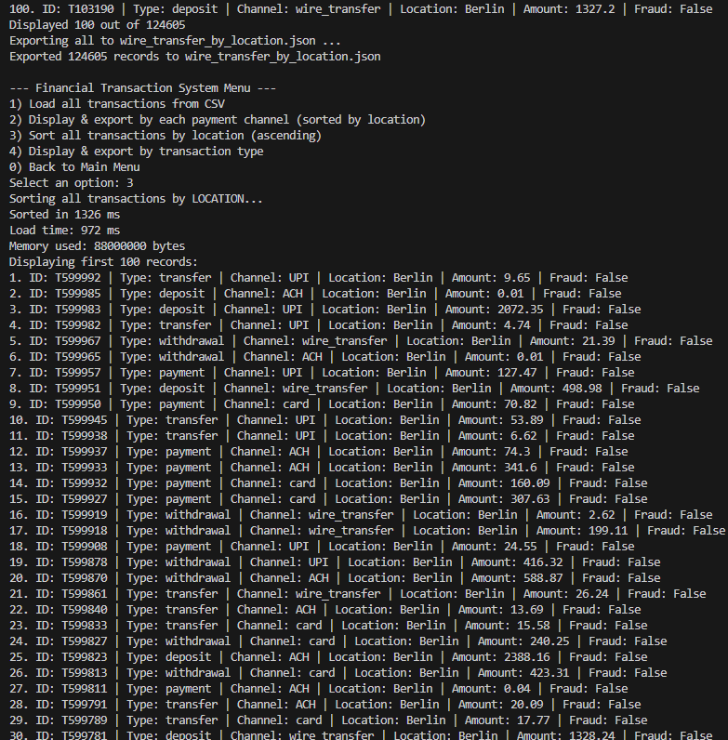
Figure 12: Output for Sort by Location “Berlin”

2.2.2 Intro Sort

2.2.2.1 Output
Array

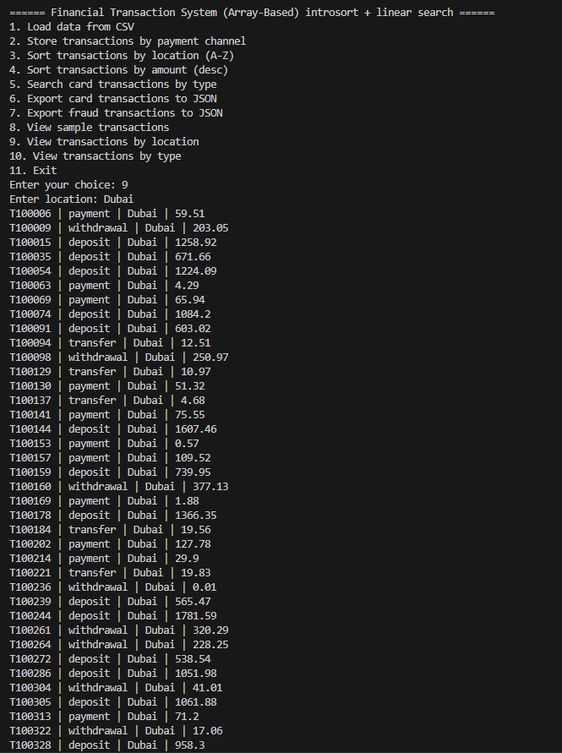
Figure 13: Output for View by Location “Dubai”

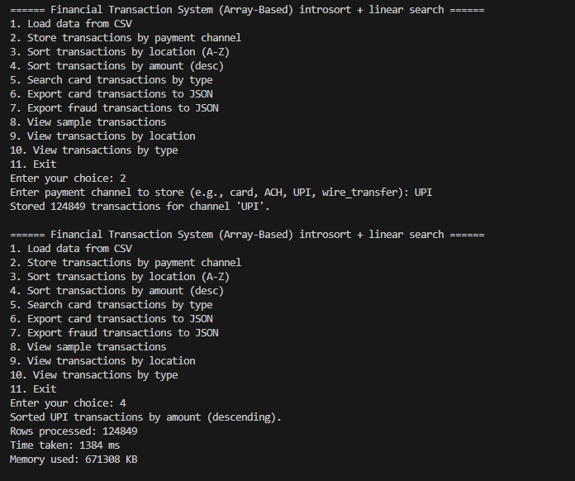
Figure 14: Output for Sort by Amount in Descending Order

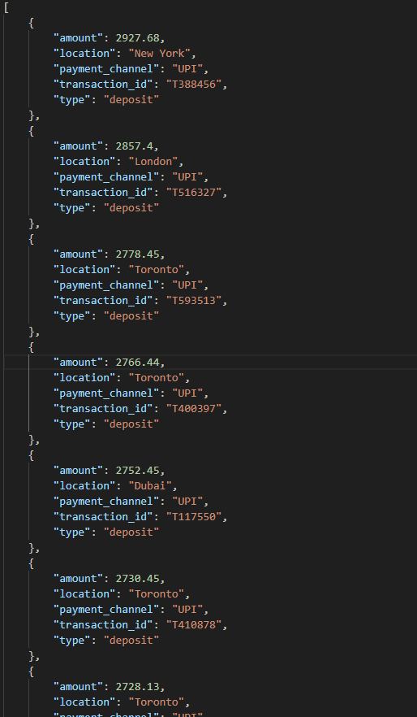
Figure 15: JSON for Amount in Descending Order

Linked List
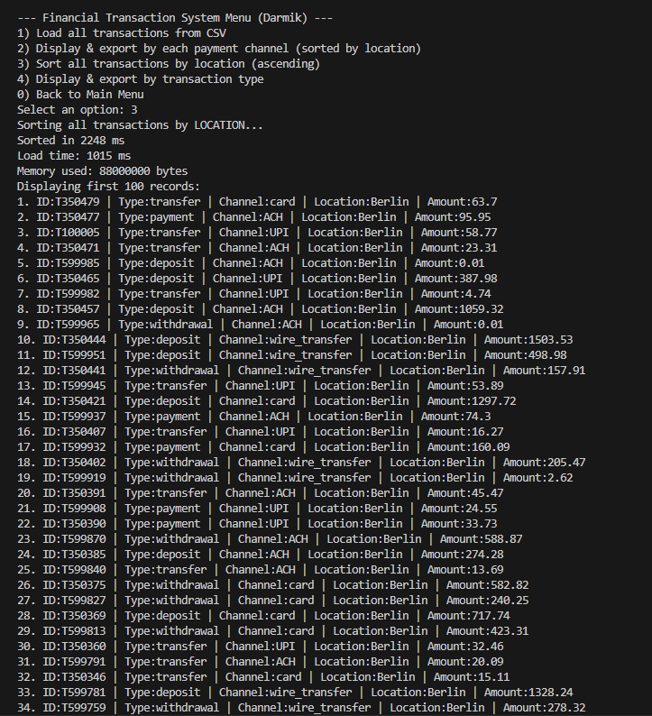
Figure 16: Output for Sort by Location “Berlin”

2.3 Searching Algorithm
2.3.1 Linear Search
2.3.1.1 Output
Array
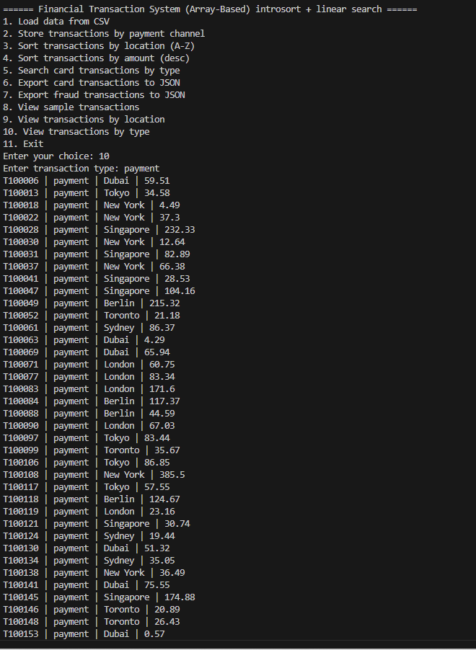
Figure 17: Search by transaction type “payment”

Linked List

2.3.2 Binary Search
2.3.2.1 Output
Array
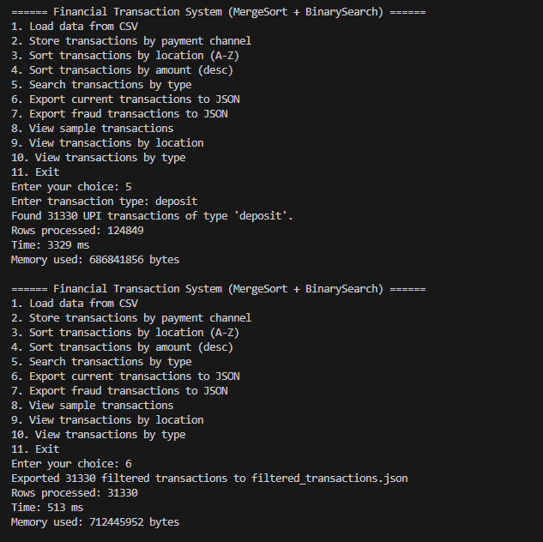
Figure 18: View Transaction by type “deposit”
Figure 19: JSON of “deposit”

Linked List
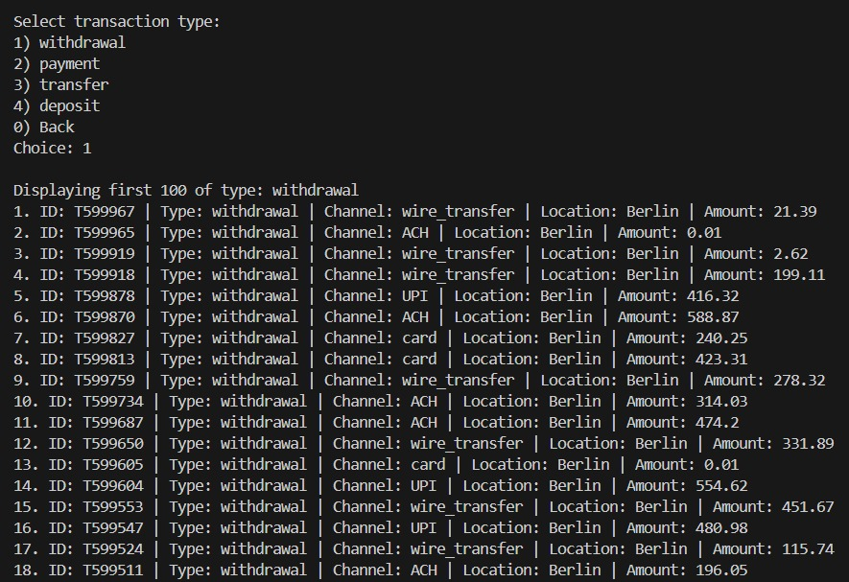
Figure 20: Sort by transaction by type “withdrawal”

3.0 Summary Discussions

3.1 Comparing Sorting Algorithm in Array

In this project, two array-based sorting methods were explored that are Merge Sort and Introsort. The Merge Sort algorithm was custom-built in the TransactionManager class. It works by splitting the data into smaller halves, sorting them recursively, and then merging the results based on specific criteria like transaction amount or location. This method gives you full control over the sorting behaviour and is ideal when the order of identical elements must be preserved. While Merge Sort guarantees consistent performance with a time complexity of O(n log n), it does require extra memory due to the use of temporary arrays during the merge process.
On the other hand, the TransactionManager class used the built-in std::sort() from C++’s Standard Library, which applies Introsort. This hybrid algorithm combines the speed of Quicksort with the fallback safety of Heapsort when recursion goes too deep, and it also switches to Insertion Sort for small chunks. Introsort isn’t stable, meaning it doesn’t always maintain the original order of equal items, but it operates directly on the array without needing extra memory. Performance testing showed that Introsort processed 124,849 UPI transactions in 1904 milliseconds, whereas Merge Sort took 3243 milliseconds to handle 124,605 wire transfer records. Introsort also used slightly less memory 667,352 KB vs 685,834 KB. However, Merge Sort still has its place when predictable ordering is a priority.

3.2 Comparing Sorting Algorithm in Linked List

When it comes to sorting data stored in linked lists, not all sorting algorithms are equally effective. Merge Sort is commonly used for linked lists due to its compatibility with their structure, while Introsort, although powerful for arrays, isn’t typically suited for linked list sorting. Merge Sort works well with linked lists because it doesn’t require random access. Instead of relying on index-based operations, it recursively splits the list into halves, sorts each half, and then merges them in sorted order. This is especially efficient for linked lists since splitting and merging can be done by simply adjusting the pointers, avoiding the need to shift data around. Merge Sort guarantees a stable sort with a time complexity of O(n log n) in all scenarios, making it predictable and reliable. It also doesn't require extra memory in the way array-based sorts often do, since merging can happen directly using existing nodes. For example, if transactions in a linked list need to be sorted by amount or location, Merge Sort ensures that records with the same value keep their original order, which is important in many financial systems. Introsort, on the other hand, is a hybrid sorting algorithm that combines Quicksort, Heapsort, and Insertion Sort. It is highly optimized for arrays, taking advantage of direct indexing and in-place sorting. However, these strengths become weaknesses when applied to linked lists. Linked lists don’t support constant-time random access, which is essential for the partitioning and heapifying steps in Introsort. Implementing Introsort for a linked list would involve significant overhead and complexity, and the performance would be poor compared to its use in arrays. Furthermore, Introsort is not stable and often sacrifices ordering of equal elements for speed, which can be a drawback in use cases where sorting stability matters. In conclusion, Merge Sort is clearly the better choice for sorting linked lists due to its stability, efficiency, and natural compatibility with pointer-based data structures. Introsort, while excellent for arrays, doesn’t translate well to linked lists and should generally be avoided in that context. Choosing the right algorithm depends heavily on the data structure being used and in the case of linked lists, Merge Sort remains the most practical and effective option.

3.3 Comparing Searching Algorithm in Array

The project also explored two search methods in array structures that are Binary Search and Linear Search. Binary Search was used in the TransactionManager class alongside Merge Sort. The array was first sorted by transaction type, and then a binary search was applied to find matching records. This approach is very efficient, with a search time of O(log n), but it requires the dataset to be sorted beforehand. It’s most effective in cases where the data is sorted once and searched multiple times afterward. In contrast, the TransactionManager class used a simpler Linear Search method through the linearsearchByType() function. This method goes through each item one by one, collecting those that match the search criteria. It’s straightforward and works regardless of the data’s order, but its performance is O(n). Based on testing, Binary Search needed 3272 milliseconds to return 30,906 "payment" results from a list of 124,605 wire transfers, this includes the time spent sorting. Meanwhile, Linear Search found similar results in just 49 milliseconds from 124,849 UPI transaction. Binary Search works best when you need to do many searches on a sorted dataset, offering high speed after an initial setup cost. Linear Search, though slower for big datasets, is ideal for quick, one-time lookups on unsorted data. In the same way, Merge Sort provides reliable ordering at the cost of time and memory, while Introsort gives you faster results with lower overhead, making it a better fit for performance-heavy use cases.

3.4 Comparing Searching Algorithm in Linked List

When working with linked lists, searching through the data is a bit different from arrays. The most suitable and often the only practical searching method for linked lists is Linear Search. This is because of how the linked list structure is designed and how data is accessed. In a linked list, each element (or node) contains data and a pointer to the next node. Unlike arrays, linked lists do not support random access you can’t jump directly to the middle or any specific position using an index. Instead, you have to start from the beginning and move node by node until you find what you’re looking for. This is exactly what Linear Search does: it checks each element one by one from the head of the list until a match is found or the end is reached. The time complexity of Linear Search is O(n), where n is the number of nodes in the list. Although this is slower than Binary Search in arrays (which is O(log n)), it’s the most straightforward and feasible option for linked lists because of the sequential nature of node access. Binary Search, on the other hand, requires the ability to quickly jump to the middle element, compare, and then move to either half of the data this is only possible in data structures with direct indexing, like arrays. In a linked list, to reach the middle node, you still have to traverse from the head, making Binary Search inefficient and not truly usable. Even if the list is sorted, Binary Search loses its advantage due to the lack of constant-time access. Therefore, Linear Search is the only practical searching algorithm for linked lists. It’s simple to implement, doesn't require the list to be sorted, and fits naturally with the linked list's pointer-based structure. While it might not be the fastest for large datasets, it remains the go-to approach when searching through linked lists, especially when ease of use and compatibility with the structure are more important than speed.

5.0 Conclusion and Reflection

5.1 Conclusion

This assignment highlighted the critical role that data structures and algorithms play in analyzing and managing financial transaction data for fraud detection. Through the implementation of both array-based and linked list-based storage systems, we were able to compare the effectiveness of different sorting and searching techniques such as Merge Sort, Introsort, Binary Search, and Linear Search. By organizing transactions by payment channels, sorting them by location, and allowing specific searches by transaction type, we demonstrated how algorithmic choices affect time and memory performance. Additionally, exporting filtered data into JSON format added real-world relevance by simulating how financial institutions might generate structured reports. The project successfully met all functional requirements while offering valuable insights into performance trade-offs between data structures.

5.2 Reflection

Working on this task was a meaningful learning experience that deepened my understanding of how foundational computer science concepts apply to real-world problems like fraud detection. One of the main challenges was optimizing the program for both speed and memory efficiency, especially when managing large transaction datasets. Through trial, error, and testing, I learned to justify algorithm selections based on the nature of the data structure and the problem at hand. The project also emphasized the importance of clear code structure, robust error handling, and practical output formats like JSON. Looking ahead, the system could be further enhanced with features such as anomaly scoring, better user interfaces, or even machine learning integration. Overall, this assignment not only helped build my technical skills in C++ but also reinforced the importance of thoughtful design and planning when developing software that deals with sensitive financial data.

6.0 Workload Matrix

MEMBER | TASK | PERCENTAGE | SIGNATURE
HEMANTHRAJAH A/L KRISHNARAJAH | - Compiling codes  - Array (Intro Sort + Linear Search) | 25% | 
ADAM JEROME JOSEPH | - Compiling codes  - Linked List ( Merge Sort + Linear Search) | 25% | 
DARMIK ISHWAR A/L RAVI | - Linked List ( Intro Sort + Linear Search) | 25% | 
ANUSHA DEVY A/P BRAHMATARAN | - Array ( Merge Sort + Binary Search) | 25% | 

6.0 References

- GeeksforGeeks. (2017, October 27). What is Array? GeeksforGeeks. https://www.geeksforgeeks.org/what-is-array/

- GeeksforGeeks. (2023, August 21). C++ Arrays. GeeksforGeeks. https://www.geeksforgeeks.org/cpp/cpp-arrays/

- ‌Chauhan, S. (2025, January 26). What is Arrays in C++ | Types of Arrays in C++ ( With Examples ). Scholarhat.com; ScholarHat. https://www.scholarhat.com/tutorial/cpp/array-in-cpp

- GeeksforGeeks. (2024, May 22). Linked List Data Structure. GeeksforGeeks. https://www.geeksforgeeks.org/dsa/linked-list-data-structure/

- W3Schools.com. (2025). W3schools.com. https://www.w3schools.com/dsa/dsa_theory_linkedlists.php

- W3Schools.com. (2025). W3schools.com. https://www.w3schools.com/dsa/dsa_algo_mergesort.php

- Merge Sort (With Code in Python/C++/Java/C). (2025). Programiz.com. https://www.programiz.com/dsa/merge-sort

- ‌BBC Bitesize. (2019, March 12). Merge sort - Searching and sorting algorithms - OCR - GCSE Computer Science Revision - OCR - BBC Bitesize. BBC Bitesize. https://www.bbc.co.uk/bitesize/guides/zjdkw6f/revision/5

- Linear Search Algorithm. (2025). Tutorialspoint.com; TutorialsPoint. https://www.tutorialspoint.com/data_structures_algorithms/linear_search_algorithm.htm

- S, R. A. (2021, August 24). What is Linear Search Algorithm | Time Complexity. Simplilearn.com; Simplilearn. https://www.simplilearn.com/tutorials/data-structure-tutorial/linear-search-algorithm

- Ghosh, A. K. (2025, January 15). What is Linear Search in Data Structures - Its Algorithm, Working, & Complexity. Scholarhat.com; ScholarHat. https://www.scholarhat.com/tutorial/datastructures/linear-search-in-data-structures

- Binary Search Algorithm. (2025). Tutorialspoint.com; TutorialsPoint. https://www.tutorialspoint.com/data_structures_algorithms/binary_search_algorithm.htm
- Binary Search (With Code). (2025). Programiz.com. https://www.programiz.com/dsa/binary-search

- Varun Saharawat. (2024, June 30). Binary Search Algorithm, Definition, Code. PW Skills Blog. https://pwskills.com/blog/binary-search-algorithm-definition-code/

‌

‌

